**ALGORITHM AND DATA STRUCTURE PRACTICUM**

**MODULE 1**

**REVIEWING**



**CREATED BY :**

**KURNIAWAN BAGASKARA**

**L200214253**

**INFORMATICS STUDY PROGRAM**

**FACULTY OF COMMUNICATION AND INFORMATION SCIENCE**

**MUHAMMADIYAH SURAKARTA UNIVERSITY**

**#latihan 1.1**

a=4

b=5

c=a+b

print('Nilai a =', a)

print('Nilai b =', b)

print('Sekarang, c = a + b =', a,'+', b,'=', c)

print('')

print('Sudah selesai.')

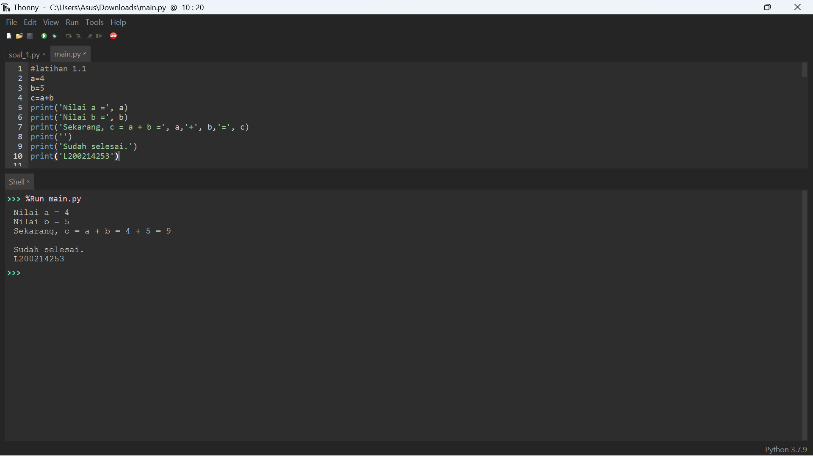

**# latihan 1.2**

print('Kita perlu bicara sebentar...')

nm = input('Siapa namamu? (ketik di sini)> ')

print('Selamat belajar,', nm)

angkaStr = input('Masukkan sebuah angka antara 1 sampai 100 > ')

a = int(angkaStr)

kuadratnya = a*a

print(nm + ', tahukah kamu bahwa', a, 'kuadrat adalah', kuadratnya,'?')

print('L200214253')

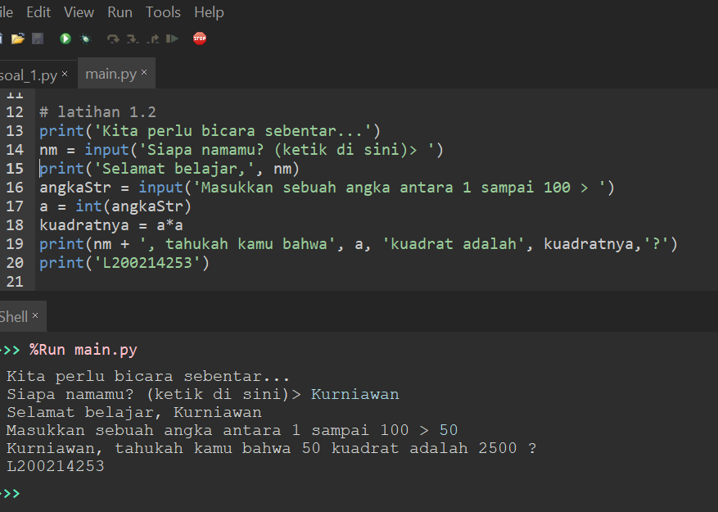

**# latihan 1.3**

def ucapkanSalam():

print("Assalamu'alaikum!")

def sapa(nama):

ucapkanSalam() # Ini memanggil fungsi ucapkanSalam() di atas.

print('Halo',nama)

print('Selamat belajar!')

def kuadratkan(b):

h = b*b

return h

print('L200214253')

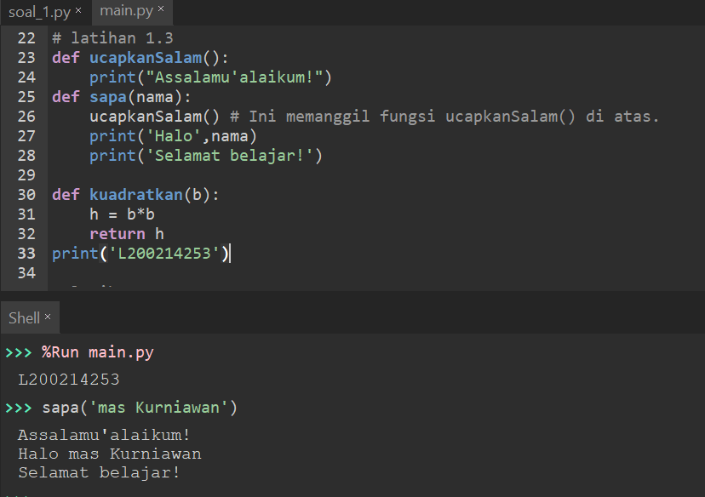

**# latihan 1.4**

from math import sqrt as akar

def selesaikanABC(a,b,c):

a = float(a) # mengubah jenis integer menjadi float

b = float(b)

c = float(c)

D = b**2 - 4*a*c

x1 = (-b + akar(D))/(2*a)

x2 = (-b - akar(D))/(2*a)

hasil = (x1,x2) # tuple yang terdiri dari dua elemen

return hasil

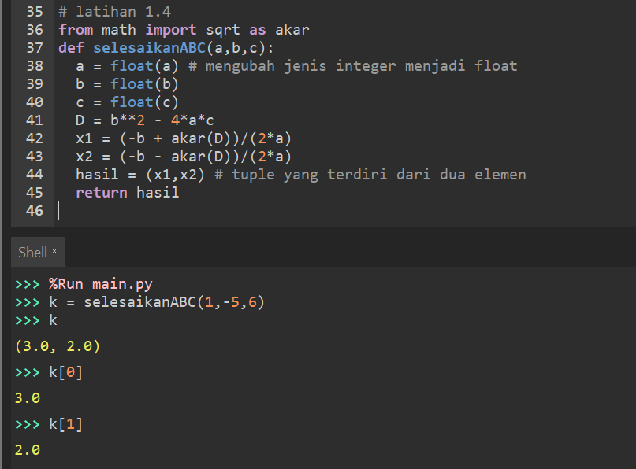

**# latihan 1.5**

def apakahGenap(x):

if (x%2 == 0):

return True

else:

return False

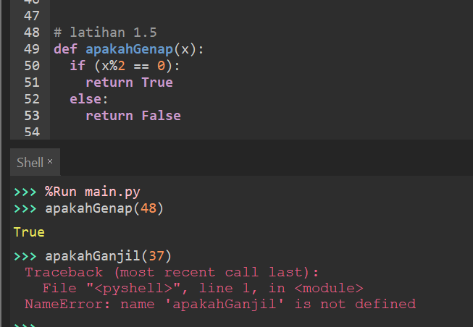

**# latihan 1.6**

def tigaAtauLima(x):

if (x%3==0 and x%5==0):

print('Bilangan itu adalah kelipatan 3 dan 5 sekaligus')

elif x%3==0:

print('Bilangan itu adalah kelipatan 3')

elif x%5==0:

print('Bilangan itu adalah kelipatan 5')

else:

print('Bilangan itu bukan kelipatan 3 maupun 5')

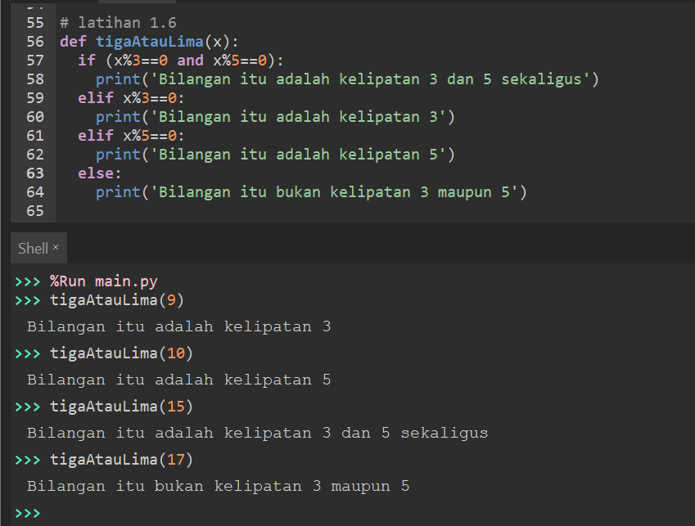

**# latihan 1.7**

staff = { 'Santi' : 'santi@ums.ac.id', \

'Jokowi' : 'jokowi@solokab.go.id', \

'Endang' : 'Endang@yahoo.com',\

'Sulastri': 'Sulastri3@gmail.com' }

yangDicari = 'Santi'

if yangDicari in staff:

print('emailnya', yangDicari, 'adalah' , staff[yangDicari])

else :

print('Tidak ada yang namanya', yangDicari)

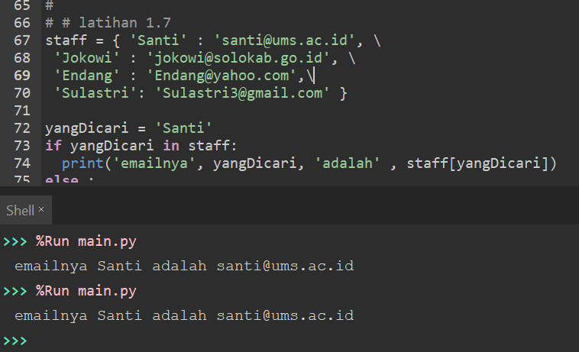

**# latihan 1.8**

for i in range (0,10):

print(i)

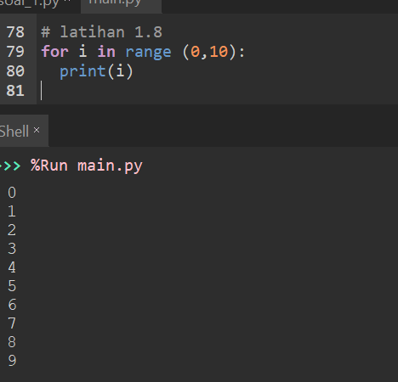

**# latihan 1.9**

s = [4, 5, 6, 7, 8]

for i in s:

print(i)

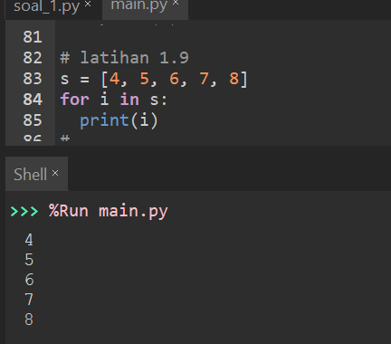

**# latihan 1.10**

dd = {'nama':'joko', 'umur':21, 'asal':'surakarta'}

for kunci in dd:

print(kunci,'<---->', dd[kunci])

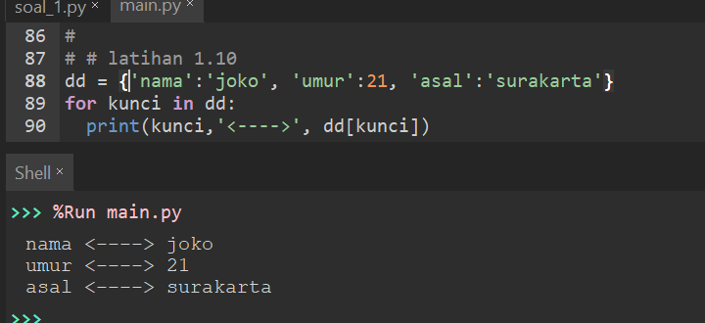

**# latihan 1.11**

bil = 0

while(bil*bil<200):

print(bil, bil*bil)

bil = bil + 1

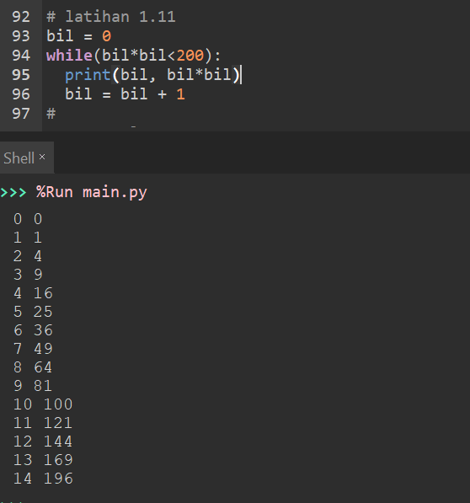

**Soal 1.**

**string = ''**

**bar = 1**

**x = int(input('Masukkan angka:'))**

**#Looping baris**

**while bar <= x:**

**kol = bar**

**#Looping kolom**

**while kol > 0:**

**string = string + '*'**

**kol = kol - 1**

**string = string + '\n'**

**bar = bar + 1**

**print(string)**

**print('Kurniawan Bagaskara')**

**print('L200214253')**

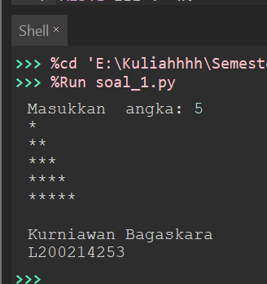

**Soal 2.**

**def persegiEmpat(x, y):**

**print('@' * y)**

**for i in range(x-2):**

**print('@'+' '*(y-2)+'@')**

**print('@'*y)**

**print('Kurniawan Bagaskara')**

**print('L200214253')**

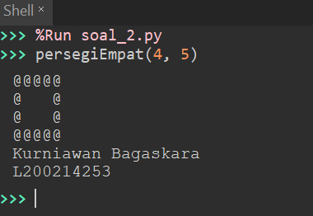

**Soal 3.**

**def jumlahHurufVokal(kata):**

**vokal = ['a', 'i', 'u', 'e', 'o']**

**kata2 = kata.lower()**

**list_kata = []**

**list_kata.append(len(kata2))**

**count = 0**

**for i in kata2:**

**if i in vokal:**

**count += 1**

**list_kata.append(count)**

**return list_kata**

**def jumlahHurufKonsonan(kata):**

**konsonan = ['b', 'c', 'd', 'f', 'g', 'h','j', 'k', 'l', 'm', 'n', 'p', 'q', 'r', 's', 't', 'v', 'w', 'x', 'y', 'z']**

**kata2 = kata.lower()**

**list_kata = []**

**list_kata.append(len(kata2))**

**count = 0**

**for i in kata2:**

**if i in konsonan:**

**count += 1**

**list_kata.append(count)**

**return list_kata**

**print(jumlahHurufVokal('Surakarta'))**

**print(jumlahHurufKonsonan('Surakarta'))**

**print('Kurniawan Bagaskara')**

**print('L200214253')**

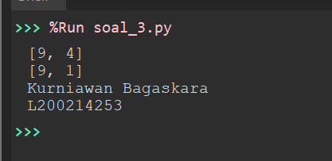

**Soal 4.**

**import statistics**

**def rerata(x):**

**hasil = float(sum(x)) / max(len(x), 1)**

**return hasil**

**def hitungVariance(x):**

**hasil = statistics.variance(x)**

**return hasil**

**def hitungStDev(x):**

**hasil = statistics.stdev(x)**

**return hasil**

**print(rerata([1,2,3,4,5]))**

**g = [3,4,5,4,3,4,5,2,2,10,11,23]**

**print(rerata(g))**

**print(hitungVariance(g))**

**print(hitungStDev(g))**

**print('Kurniawan Bagaskara')**

**print('L200214253')**

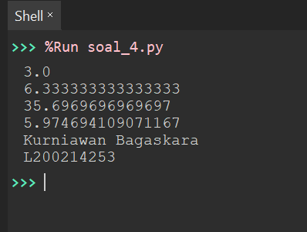

**Soal 5.**

**from math import sqrt as sq**

**def apakahPrima(n):**

**n = int(n)**

**assert n >= 0**

**primaKecil = [2,3,5,7,11]**

**bukanPrKecil = [0,1,4,6,8,9,10]**

**if n in primaKecil:**

**return True**

**elif n in bukanPrKecil:**

**return False**

**else:**

**for i in range(2, int(sq(n)) + 1):**

**if n % i == 0:**

**return False**

**return True**

**print('Kurniawan Bagaskara')**

**print('L200214253')**

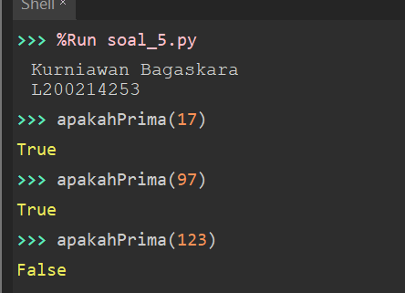

**Soal 6.**

**def is_prima(x):**

**for i in range(2, x):**

**if x % i == 0:**

**return False**

**return True**

**def bilangan_prima (awal, akhir):**

**list_bilangan_prima = []**

**for x in range(awal, akhir + 1):**

**if is_prima(x):**

**list_bilangan_prima.append(x)**

**return list_bilangan_prima**

**print(bilangan_prima(2, 1000))**

**print('Kurniawan Bagaskara')**

**print('L200214253')**

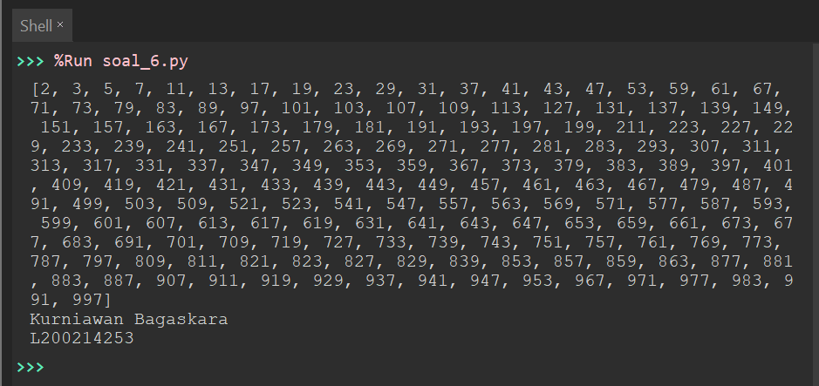

**Soal 7.**

**def faktorPrima(x):**

**faktor=[]**

**loop=2**

**while loop<=x:**

**if x%loop==0:**

**x/=loop**

**faktor.append(loop)**

**else:**

**loop+=1**

**return faktor**

**print('Kurniawan Bagaskara')**

**print('L200214253')**

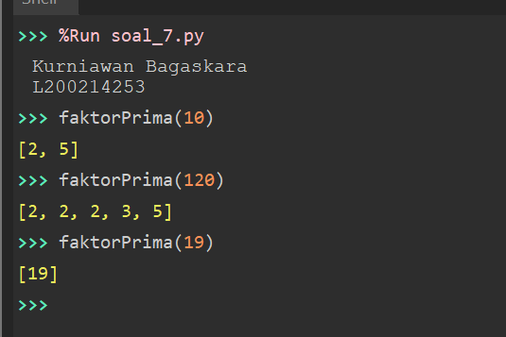

**Soal 8.**

**def apakahTerkandung(x, y):**

**for k in x:**

**if k in y:**

**return True**

**else:**

**return False**

**print('Kurniawan Bagaskara')**

**print('L200214253')**

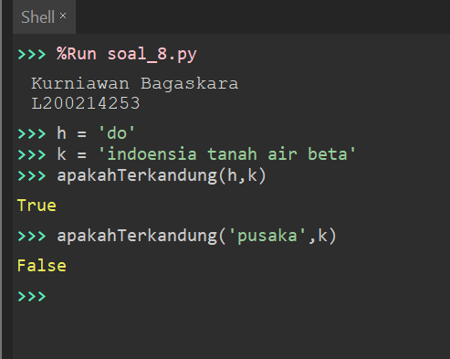

**Soal 9.**

**for i in range(1, 100):**

**if (i % 3 == 0 and i % 5 == 0):**

**print ('Python UMS')**

**elif i % 3 == 0:**

**print ('Python')**

**elif i % 5 == 0:**

**print('UMS')**

**else:**

**print(i)**

**print('Kurniawan Bagaskara')**

**print('L200214253')**

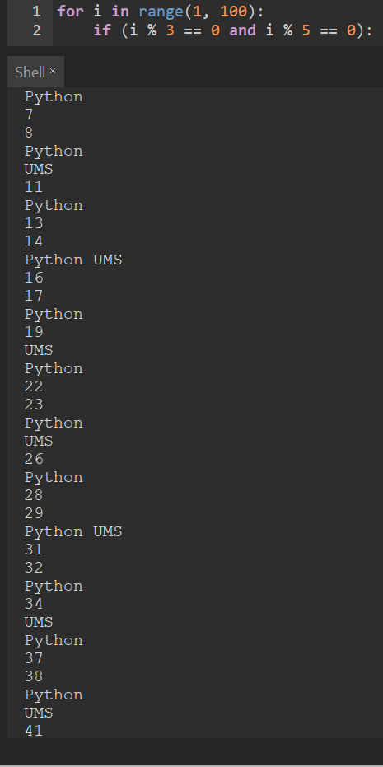

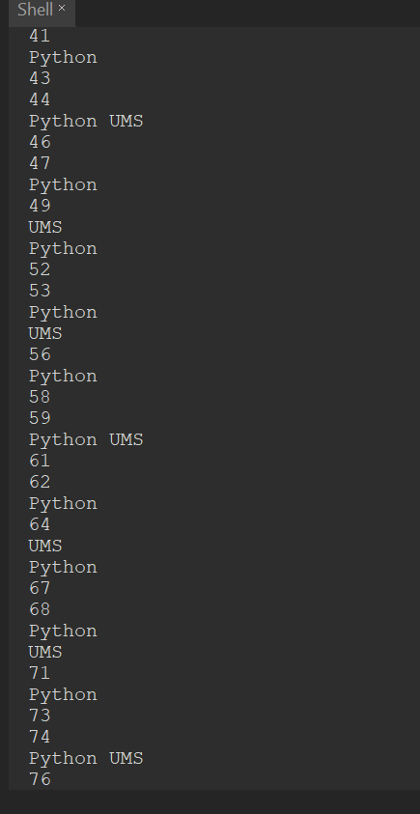

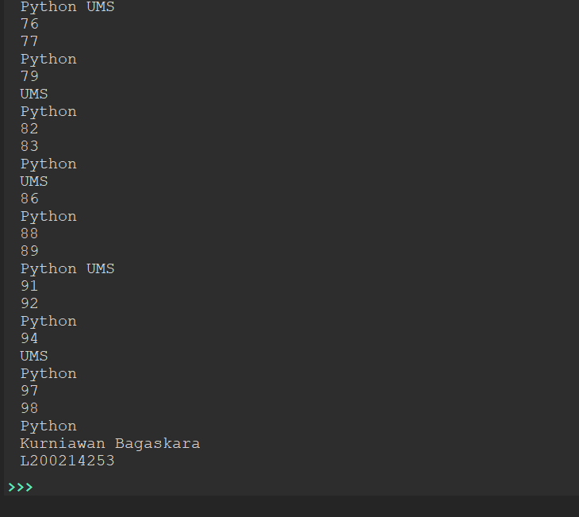

**Soal 10.**

**def selesaikanABC(a, b, c):**

**a=float(a)**

**b=float(b)**

**c=float(c)**

**D=(b**2) - (4*a*c)**

**if D<0:**

**return 'Determinanya negatif. Persamaan tidak mempunyai akar real'**

**else:**

**x1=(-b + sq(D))/2*a**

**x2=(-b - sq(D))/2*a**

**hasil=(x1, x2)**

**return hasil**

**print('Kurniawan Bagaskara')**

**print('L200214253')**

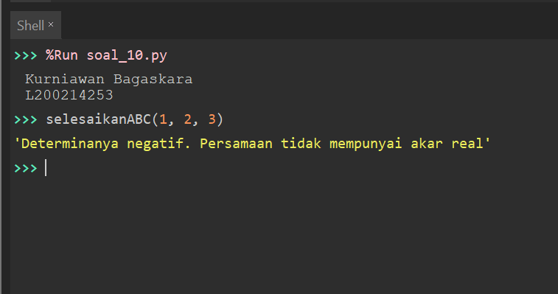

**Soal 11.**

**def apakabarKabisat(x):**

**if (x % 4) == 0 and (x % 100) == 0 and (x % 400) != 0:**

**return False**

**elif (x % 4) == 0:**

**return True**

**else:**

**return False**

**print('Kurniawan Bagaskara')**

**print('L200214253')**

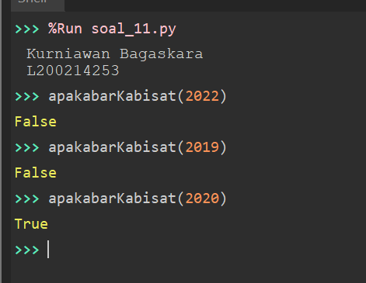

**Soal 12.**

**from random import randint**

**quiz = randint(1, 100)**

**print('Saya menyimpan angka bulat antara 1 sampai 100. coba tebak')**

**jawab = 0**

**count = 1**

**while jawab != quiz:**

**jawab = input('Masukkan tebakan ke-{}:>'.format(count))**

**jawab = int(jawab)**

**if jawab == quiz:**

**print('Ya. Anda Benar')**

**elif jawab < quiz:**

**print('Itu terlalu kecil. Coba lagi')**

**else:**

**print('Itu terlalu besar. Coba lagi')**

**count += 1**

**print('Kurniawan Bagaskara')**

**print('L200214253')**

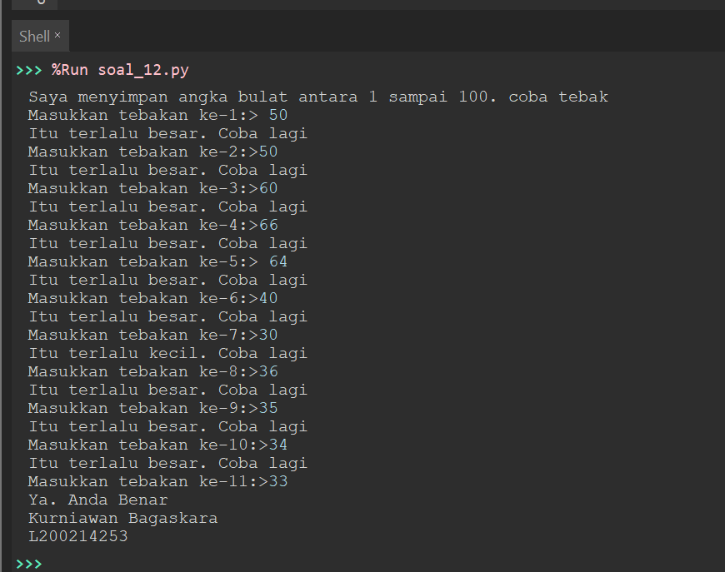

**Soal 13.**

**def katakan(angka):**

**di_bawah20 = ['Nol', 'Satu', 'Dua', 'Tiga', 'Empat', 'Lima', 'Enam', 'Tujuh', 'Delapan',**

**'Sembilan', 'Sepuluh', 'Sebelas', 'Dua belas', 'Tiga belas', 'Empat belas', 'Lima belas',**

**'Enam belas', 'Tujuh belas', 'Delapan belas', 'Sembilan belas']**

**puluhan = ['Dua puluh', 'Tiga puluh', 'Empat puluh', 'Lima puluh', 'Enam puluh', 'Tujuh puluh',**

**'Delapan puluh', 'Sembilan puluh']**

**di_atas100 = {**

**100 : 'ratus',**

**1000 : 'ribu',**

**1000000 : 'juta',**

**}**

**assert angka >= 0**

**assert angka < 1000000000**

**if angka < 20:**

**return di_bawah20[angka]**

**if angka < 100:**

**return puluhan[(int)(angka/10)-2] + ('' if angka % 10==0 else ' ' + di_bawah20[angka % 10])**

**pivot = max([key for key in di_atas100.keys() if key <= angka])**

**#Recursion**

**hasil = katakan((int)(angka/pivot)) + ' ' + di_atas100[pivot] + ('' if angka % pivot==0 else ' ' + katakan(angka % pivot))**

**if 'Satu ratus' in hasil:**

**hasil = hasil.replace('Satu ', 'Se')**

**return hasil.capitalize()**

**print('Kurniawan Bagaskara')**

**print('L200214253')**

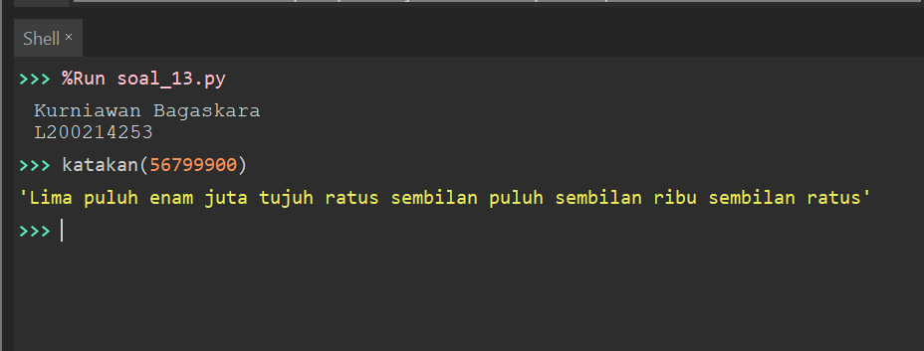

**Soal 14.**

**def formatRupiah(n):**

**x = '{:,}'.format(n).replace(',', '.')**

**return 'Rp ' + x**

**print('Kurniawan Bagaskara')**

**print('L200214253')**

